Documentation for RFID SM 130 and USB-to-Serial

Wiring

Pins 7 and 8 on the shield are the Tx and Rx pins on the SM130. Power, 5v, and ground are labeled as such on the shield. Wire pin 1 on the USB to serial to ground, pin 2 to pin 7, pin 3 to power/5v, and pin 4 to pin 8. both Vin and 5v should be wired to an external power (5v), and both grounds should be wired to an external ground.
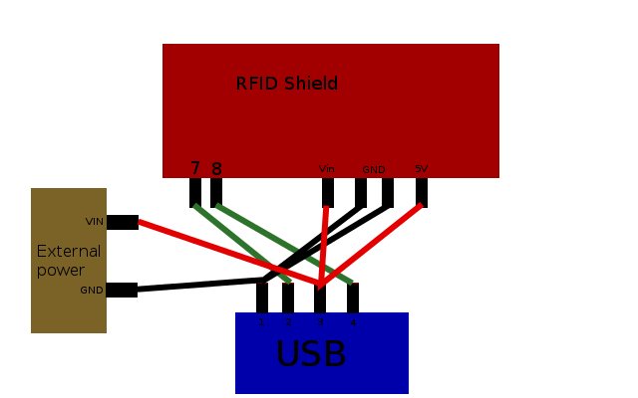

Commands

Further documentation on commands can be found on the SM130 datasheet https://www.sparkfun.com/datasheets/Sensors/ID/SM130.pdf

Commands sent to the SM130 take the following format.
-First, 0xFF and 0x00 are sent. These are reserved signals, and must proceed any command.
-Next, the byte length of the command to follow is sent. This includes the command itself, all data, but not the checksum. For example, the seek command has a length of 0x01, while the write command has a length of 0x12.
-Next, the command itself is sent. This will be a single byte. See the SM130 documentation for a full command list.
-Following the command, the data that the command carries must be sent. Some commands, like seek, have no data.
-Lastly, a checksum, consisting of a single byte, is sent. This is the sum of all the entered bytes, save the first 2, modulus 0xFF. For instance, the seek command, which consists of a length byte equal to one and a command byte equal to 0x82, has a checksum of 0x83.

After sending this information, the tag will send a response back through the scanner. In general, this response will consist of the number of bytes to be sent, the command the tag received, a code signaling whether the command was successful, and then some data returned by the command.

Notable responses to remember are 4E and 46, both of which signify that that the tag was inaccessible, but that the command was sent. These responses tend to commonly occur when the authentication command is not properly sent.

Sample Command

This is a sample command sequence that would write the string “AAAAAAAAAAAAAAAA” to block 1 of a tag. Comments will be proceeded by “//”
0XFF 0x00 0x01 0x82 0x83 //Seek for a tag. Hangs the sm130 until a tag is found.
0xFF 0x00 0x03 0x84 0x01 0xFF 0x89 //authenticates block one
0xFF 0x00 0x12 0x89 0x01 0x41 0x41 0x41 0x41 0x41 0x41 0x41 0x41 0x41 0x41 0x41 0x41 0x41 0x41 0x41 0x41 0xAF // writes to block one, checksum is 0xAF.

PySerial
We are using the pyserial library to send commands via usb to the RFID shield. More information on pyserial can be found on its API page, http://pyserial.sourceforge.net/pyserial_api.html.
Pyserial is a very simple library. In order to use it, one must create a serial object, ie, ser = serial.Serial().
The serial objects has two parameters of note, baudrate and port. Baudrate should be set to 19200 for communication with the RFID. The port will be a string, and should be set to whatever port the usb is plugged into. On a PC, this is often “COMX”, where x is an integer. On Ubuntu, the port will be “/dev/ttyUSBX”, where x is an integer. Unless other USB serial devices are plugged in, on Ubuntu the x will be 0.
Once baudrate and port are set, (ser.port = “COM4”, ser.baudrate = 19200), the port must be opened. This can be accomplished by calling the open() command. We can check if the port opened successfully by calling isOpen(), which returns true if the port is open. Similarly, close() closes the port, and isClosed() returns true if the port successfully closed. Note that closing the port is only necessary when all commands have been sent, and the port will close itself if the USB is unplugged.

Once we have opened the port (ser.open()), we can send commands to the RFID by calling the write function. This function takes a list or tuple, and will return the number of bytes written. For instance, ser.write((0xFF, 0x00, 0x01, 0x82, 0x83)) will call the seek function. A single byte can also be sent, by placing it in a tuple as in (0xFF, ). note the trailing comma, which is in fact necessary.
The read(n) method will pop the bytes on the top of the USB's stack. Read will read in the n bytes from the stack, and returns a list of n bytes from the stack. Read(3)[2] will pop off 3 bytes and return the last one.

RFIDlib
RFIDlib is a python class that calls a pyserial instance. It opens a port as part of its instantiation. By calling an instance of RFIDlib, we can easily call functions on the RFID. The seek, authenticate, read, and write functions are implemented as callable methods within RFIDlib. See comments within the class for exact usage.

Tools.py
This class calls a RFIDlib instance and uses it for several utiliy functions. It can write initial positions to tags and reset the data on tags. It is mainly for debugging connivance.

Information on tags
On each of the tags we have a position stored. This position is in the 4th and 3rd to last bytes in the first block of each tag as x and y coordinates. Furthermore, we will have the last position found will be saved to the 2nd to last and last bytes on the first block as lx, ly. In this way we can see which direction the last bot to find a tag came from. Finally, we store a binary list of all tags found in blocks 2 -4. Byte 0 of block represents tag 1 being found, and byte 15 of tag 4 represents tag 48 being found. When a tag is found by a bot, it's list of tags is merged with the list stored on the robot and then rewritten to both the robot and the tag. In this way, we can track how many tags have been found, and also find our stop condition (all tags have been found)

